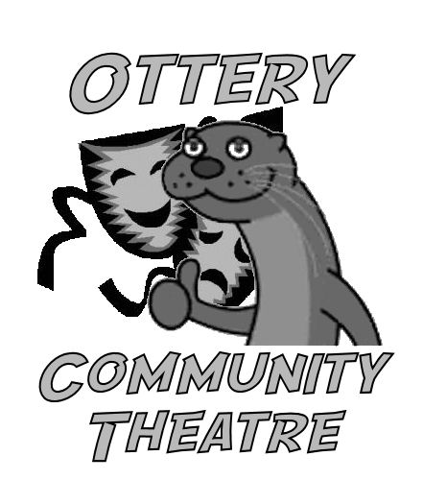
Ottery Community Theatre

Data Protection and Use of lmages

Ottery Community Theatre (OCT) intends to comply with current General Data Protection Regulations and thus needs to inform you that your data will be held on the legitimate interest basis.

We use a password-protected e-mail account to store your contact details and send you our newsletter. If you choose not to allow your details to be used in this way, please be aware that it will be your responsibility to contact us to find out about our productions and activities.

If you wish to take part in a production or activity, then it is in our legitimate interest that we must be allowed to use your image. OCT uses images for promotional purposes such as in publications that we produce, on our website or on display boards. We may also make film recordings. In addition, the media may take photographs or recordings at productions which may subsequently appear in newspapers or on television. We will not use any images that might be considered risqué and will only give your first and last name, seeking your approval prior to any other information being published.

----------------------------------------------------------------------------------------------------------------

Name of member (block capitals) _________________________________________

I give my permission for my contact details to be held on OCT’s e-mail account YES/NO

I give my permission to be added to the newsletter mailing list YES/NO

I am aware that my details will continue to be held and I will remain on the newsletter list if I cease to be a member until I ask to be removed.

By taking part in OCT productions and activities, I confirm that:

- rehearsals and performances may be filmed, with those films being distributed as appropriate, and I consent to being filmed.
- my image may be used on the OCT website or social media sites (eg Facebook).
- my image may be used in publicity and promotional material (eg display boards, newspapers, Tourist Information Centre web-site and Facebook page)
- OCT cannot be held responsible for the use and distribution of unofficial images (eg backstage photos taken by cast members, newspaper photos of carnival procession).
- I must immediately notify a responsible person at OCT if inappropriate images are taken.

Signature of performer or, for performers under 18, parent or legal guardian

________________________________________ Date ___________________

